Why is Harrison not going to nursery?

Harrison and all the children and teachers from nursery are staying at home.

Harrison and all the children are staying at home, this is so we can try and stop people getting a virus and being ill. This will help us all stay safe.

As well as staying at home Harrison can keep safe by washing his hands when his mum and dad ask him to.

Staying at home, Harrison might feel sad or angry, this is ok. Harrison can hug his mum and dad if he feels sad. Harrison can squeeze a teddy or pillow if he feels angry.

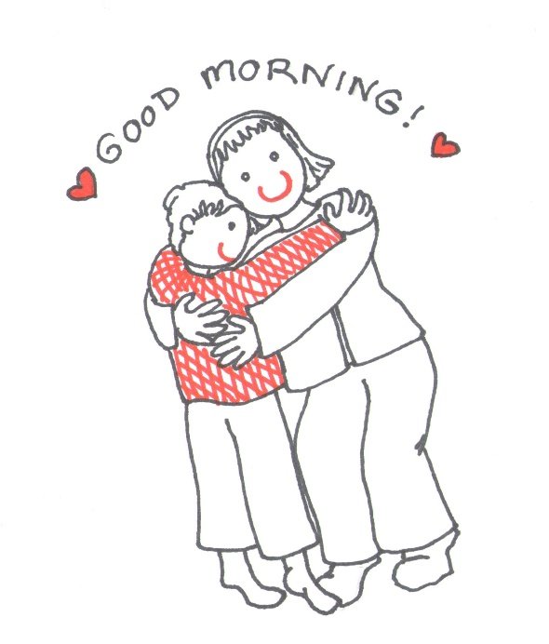

Harrisons mum and dad are trying to keeping him safe at home. The teachers will let Harrisons mum and dad know when it is time to go back to school. Harrison can play at home until the teachers call.

