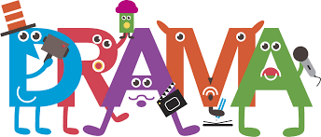 Pathway 3 Activities:

Emotions Game
Skills being developed: Attention, emotional and self-awareness, social.

Spend some time talking to your child about different emotions. The list could include: happy, sad, excited, scared, calm, angry, surprised, disgusted, brave, sorrowful, amused and determined. Explain that people behave, talk and look differently depending on how they are feeling.

Go through each emotion on the list and show your child how your face and body language might look if you are feeling that emotion. Eg. “When I’m feeling happy I smile, I sit tall with my shoulders back and my head held high” – and show them your happy smiling face and body. Ask your child to copy you.

Once you have tried each emotion together, name an emotion and see if they can show you what the emotion looks like before you do it. Eventually, take it in turns to create a still pose of the emotion after it has been called out.

If you wish, extend the activity from doing still poses, to a mini sketch. Eg. for excited, you might jump up and down, smile and clap your hands saying “oh my goodness, I can’t believe we’re going on holiday today, I can’t wait”. These acting sketches can be as short or as long as you wish.

Variations – things to try:
- Turn the activity into a guessing game. You will show them a pose and they will guess what emotion you are feeling. Swap roles once they have got the idea.
- Develop them into a scene where two people are in a particular setting together (eg. the dinner table), but feeling different emotions eg. one of you is angry and the other is happy.

Don’t forget…
Help your child in whatever way they need, remind them it is ok to make mistakes, and reward their efforts with praise and positivity!
What am I doing? / Where am I? / Who am I?
Skills being developed: Observation and attention, communication, improvisation and creativity.

To begin, tell your child that you are going to mine (act out) something, and their job is to guess what you are doing. Choose a simple action eg. brushing your hair, and act it out for them. If they guess correctly, then move on to the next one. If not, give them a choice of 2, eg. “am I brushing my hair or tying my shoelaces?” and see if they can guess.

If they answer “drinking coffee” instead of “drinking tea”, then they are still correct, just say “yes, I was drinking tea, but I could also be drinking coffee”

Once you have acted out a few, encourage your child to have a go. Give them whatever help they need whilst encouraging independence – they may feel quite self-conscious to begin with so be patient if they need more time.

Eventually the game can evolve into a turn taking game (between 2 or more of you), and (depending on your child’s needs) you can even add competition to the game by awarding a point for every correctly guessed action.

Below are a list of suggestions of things that you can act out:

- Eating a burger
- Digging a hole
- Blowing out candles
- Eating a packet of crisps
- Bouncing a ball
- Putting on trousers
- Brushing your hair
- Blowing your nose
- Playing tennis
- Painting a picture
- Taking a photo
- Washing the dishes
- Frying a pancake
- Drinking tea
- Chopping vegetables
- Typing on a laptop
- Playing football
- Playing a computer game
- Reading a book
- Driving a car
- Talking on the phone
- Tying your shoelaces
- Brushing your teeth
- Making a cake
- Putting on your coat
- …any others you can think of!

Once you have got the hang of “What am I doing?” you can have a go at “Where am I?”…

For “Where am I?”, the process is the same but instead of acting out something you are doing, you must act as though you are in a particular place (but without saying the name of the place of course). For example, if you are pretending to be at the beach you might act out putting down a towel on the floor, rubbing in sun cream, putting on sunglasses, building a sandcastle etc.

It is likely that because your child is familiar by now with the idea of identifying what you are doing, they may call out “sunbathing”, “making sandcastles” or “splashing in the sea”. If this happens, encourage them to answer the where part of the question by saying “yes – I am sunbathing, so WHERE am I?”
If they still struggle, try giving them 2 choices, eg “Am I at the beach or at the supermarket?” to help them to identify the answer.

If they answer “At the seaside” instead of “at the beach”, then they are still correct, just say “yes, I’m at the seaside, or you could also say at the beach”.

Below are a list of places where you could pretend to be:

- At the beach
- At the cinema
- On a bus
- In the bath
- At the park (by a pond)
- In a playground
- On a boat
- In the shower
- At the dentist
- On a rollercoaster
- In a restaurant
- Out in the snow
- In a classroom
- In the school dining hall
- In a bedroom
- At the supermarket
- At a party/disco
- At the gym
- A place of worship
- …any others you can think of

It is important that if your child is not getting it, you change what you are doing to try a different way of showing where you are. Try to stick to places that your child is familiar with and activities that they identify with those places.

The final game to try is “Who am I?”

As with the last 2, the process of play is the same, however this time instead of guessing what you are doing or where you are, they need to guess who you are pretending to be.

For example, if you are pretending to be a popstar, you would mime holding a microphone and singing. As with before, it is likely that because your child is familiar by now with the idea of identifying what you are doing, or where you are pretending to be, they may call out “singing” or “at a concert”. If this happens, encourage them to answer the who part of the question by saying “Yes, I am singing at a concert, so WHO am I?” If they still struggle, try giving them 2 choices, eg “Am I a popstar or a dentist?” to help them to identify the answer.

If they answer “Taylor Swift” instead of “popstar”, then they are still correct, just say “yes, I could be Taylor swift – I’m a popstar! Well done!”

Below are a list of people that you could pretend to be:

- Fireman
- Dentist
- Teacher
- Vet
- Builder
- Doctor
- Policeman
- Gardener
- Shop assistant
- Postman
- Popstar
- Chef
- Clown
- Dancer
- Athlete
- Astronaut
- Artist
- Bus driver
- Cleaner
- Parking warden
- Waiter/waitress
- Musician
- Beautician
- Hairdresser/Barber
- Mechanic
- Pilot
- Tourist
- DJ
- Footballer
- Ice skater
- …any others that your child will know

Variations – things to try:
- Add in sound effects to your acting to make the actions more interesting and clear.
- Extend the actions into a mini ‘scene’ in which you narrate as you go. Eg. “Right, where are my eggs? Ah here they are (pretend to break eggs into a bowl). Sugar next, let me measure it out…(pretend to measure sugar and pour it into the bowl and stir it up).” Etc.
This can make the acting easier to understand and more entertaining as you can add humour to the scene to keep them interested – “oops, dropped an egg on the table, ugh look it’s all over my hands!”

Remember to keep your actions simple and clear to begin with, building them up as your child becomes more familiar with the game and starts to need more of a challenge. Most importantly ensure to keep it light hearted and fun so that their confidence in performing build.

Don’t forget…
Help your child in whatever way they need, remind them it is ok to make mistakes, and reward their efforts with praise and positivity!

Ways to move/travel – Remote control version

Skills being developed: Creativity, gross motor, physical control and special awareness.

This activity can be done in the garden or in an open space indoors (eg. Living room) – it does not need to be a big space, but useful to not have any small objects on the floor that you could trip over.

Stand in the space and say “we are standing still”.

One your child is still, say “let’s walk”, and begin to walk slowly around the space, either in a random direction or in a circle if you prefer. If needed – hold your child’s hand or guide them with one hand on their shoulder.

After a few seconds, say “STOP! Now we are on a bike. GO!”
Start to move around the space again, but this time pretending to ride a bicycle.

Once you have travelled a few times around in the circle in this way, say “STOP! Now we are walking in sticky, gooey mud. GO!” and begin walking around as if you are squelching through mud.

Keep repeating, instructing your child to move in the following ways:

- Driving a car
- Like a King/Queen
- Swimming
- Like a soldier
- Riding a horse
- Like a robot
- On ice
- Through a blizzard/snow storm
- Like an astronaut on the moon
- In the dark
- Like a dancer
- Through a river
- Through a jungle
- With a book on your head
- …any others you can think of that your child might enjoy!

Next, using a remote control as a prop, tell your child that you are now in control of when and how they will move. When you point your remote control and call out “play” they will start moving. When you call out “pause” they will freeze on the spot, when you call out “fast forward” they will go faster, when you call out “rewind” they will move backwards, and when you call out “stop”, the game is over.

Begin the game by asking your child to simply walk around in the space and then use the remote control to instruct their movements. Next, swap places and let your child control the remote whilst you move around the space.

Finally, extend this activity by choosing one of the ways to move from the above list, and ask them to move eg. like a robot whilst you direct them using the remote control.

Keep it fun, and always ensure that you play this game safely and stop playing if it starts to get out of control – you can try again another day!

Don’t forget…
Help your child in whatever way they need, remind them it is ok to make mistakes, and reward their efforts with praise and positivity!

It is a… but it could be a…

Skills being developed: Creativity, improvisation, communication and imagination.

For this game you will need a selection of household items (clean and safe for use) such as:

- Wooden/plastic spoon
- Large bowl/bucket
- Scarf/shawl
- Toothbrush
- Pillow/cushion
- Remote control

Tell your child you are going to play an imaginary game where you change the purpose of an object.

Choose one of the items you have collected, eg. a wooden spoon. Hold the object in your hand and say “It is a wooden spoon” and mime stirring a pot with it, then say “But it could be a tennis racquet”, and mime playing a game of tennis using the wooden spoon as if it were a tennis racquet.

Now it is your Childs’ turn. Hand them the wooden spoon and ask them to say “It is a wooden spoon” and mime using it as a spoon. Next, ask them to say “but it could be a…” and wait to see if they come up with a way that the spoon could be used as though it were a different object. If they are struggling to think of something, offer them suggestions such as “hair brush”, or “pen”, and encourage them to act it out using the wooden spoon.

Once you have done a few different mimes with the spoon, or have run out of ideas, move on to the next prop. Every time begin by saying “It is a (name of prop)” and mime using the prop how it is meant to be used, and then say “but it could be a (name of a different object”. Feel free to make your answers as silly and outrageous as you like – keep it fun!

To help, here are some suggestions of ‘alternative objects’ that you could mime with the suggested items:

- “It is a wooden spoon, but it could be a…
tennis racket/hairbrush/pen/umbrella/wand/sword/walking stick”

- “It is a bowl, but it could be a…
hat/steering wheel/drum/sink/cauldron/pillow/trowel”

- “It is a scarf, but it could be a…
rope/lasso/snake/skipping rope/towel/blanket/superhero cape”

- “It is a toothbrush, but it could be a…
Flute/hammer/candle/drumstick/lollipop/key/knife”

- “It is a pillow, but it could be a…
boat/sponge/plate/laptop/punch bag/napkin/flying carpet

- “It is a remote control, but it could be a…
Phone/rocket ship/chocolate bar/cloth/toothbrush/mirror/book

Remind your child to handle the props with the appropriate care, always ensure that you play this game safely and stop playing if it starts to get out of control – you can try again another day!

Don’t forget…
Help your child in whatever way they need, remind them it is ok to make mistakes, and reward their efforts with praise and positivity!

Visuals below to support activities

Pathway 3 Activities:
VISUAL AIDS

Emotions Game
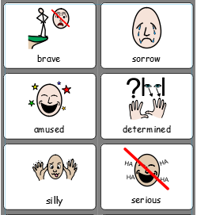
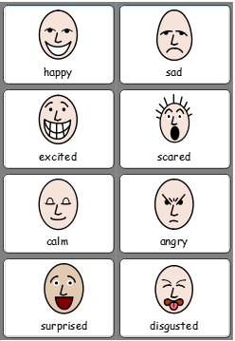
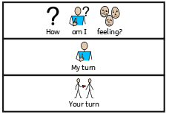

What am I doing?
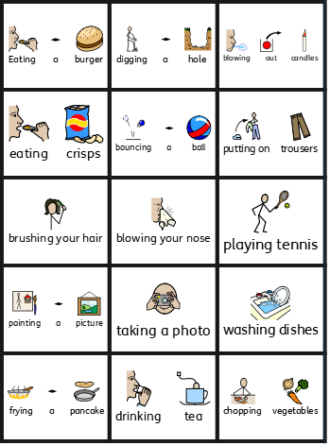
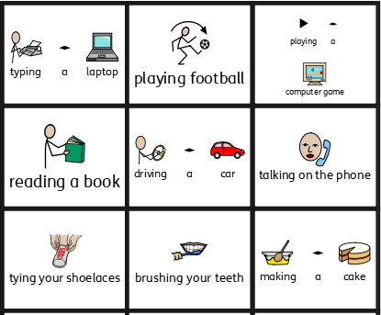

Where am I?
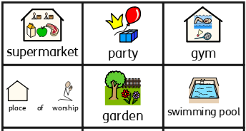
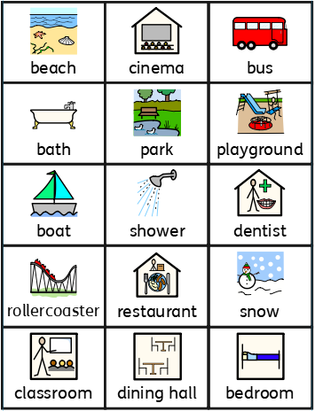

Who am I?

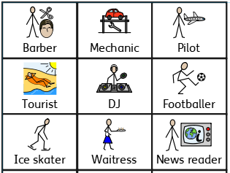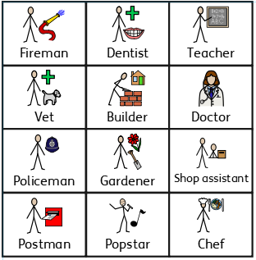

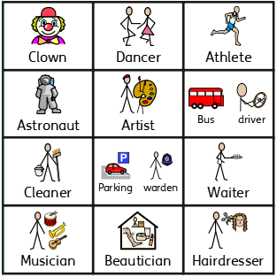

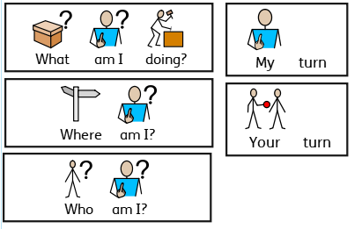

Ways to move/travel – Remote control version

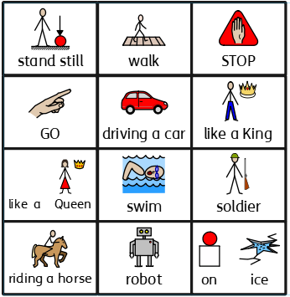
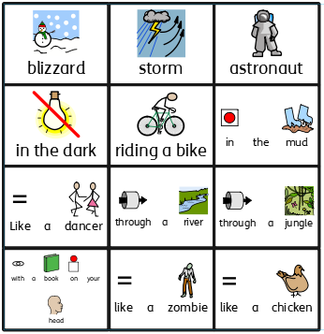
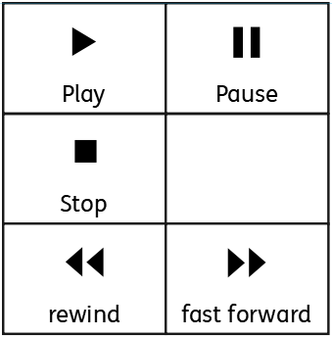

It is a… but it could be a…

