Reading Ideas for Home

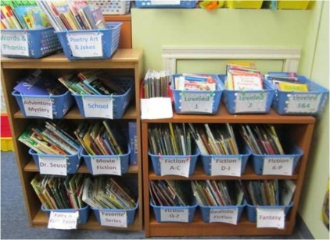
- Encourage your child to read one of their favourite books to you. Talk about why they like it and see if the can tell you about their favourite part. You could also read your favourite book to them and talk about it together after.

- Ask your child to predict what might happen next in an unfamiliar story before turn the page.

- Talk about how the characters feel in a story and why they might feel like that.

- Organise any books you have a home into alphabetical order by author or into genres.

- Visit your local library if you can and choose a fiction and non-fiction book to take home.

- Choose a word of the day and see how quickly you can find it in dictionary (online or hard copy). Before you read the definition prediction what the word might mean. Talk about other words that might mean the same thing and then look in a thesaurus (online or hard copy) to see how many words you guessed are in there.

- Think of a household item and use the index in the Argos catalogue to find it.

- Look at newspapers together, identify which part are headlines, captions and stories. Choose a story you feel would be interesting and read it together.

- Look at the TV guide or timetable online and work out what you would like to watch today.

- Turn the sound off the TV and read the subtitles.

- Read a range of film reviews to decide what to watch in the evening

- Find the words to your favourite song on the internet and learn the lyrics

- Encourage a child to read out a recipe to you while you cook together.

- Give your child the shopping list and encourage them on being in charge of what you need to buy
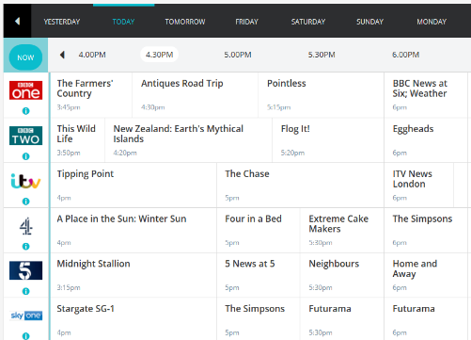
- Order a takeaway and encourage your child to read off the menu

- Plant some flowers and ask your child to read the planting instructions.

- Read a play together taking on different character roles. Encourage your child to read with emotion and expression

- Read a poem together

