Maths Home learning activities

Pathway 1
Number:
- Sing counting rhymes and songs, such as Five Little Ducks, act it out using your fingers or objects that your child can see and touch.
- Make the most of dressing, bedtime, shopping and other everyday activities to count stairs, buttons, cups, or anything else.
- Let your child help you to set places at the table. Help them by saying “a cup for me, a cup for you”.
- Let your child help you to sort the washing into piles or match socks.
- Let your child help you tidy up by putting similar items together, such as all the spoons in a pile, or matching saucepans with their lids.
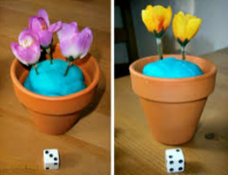
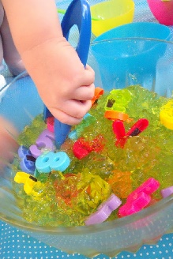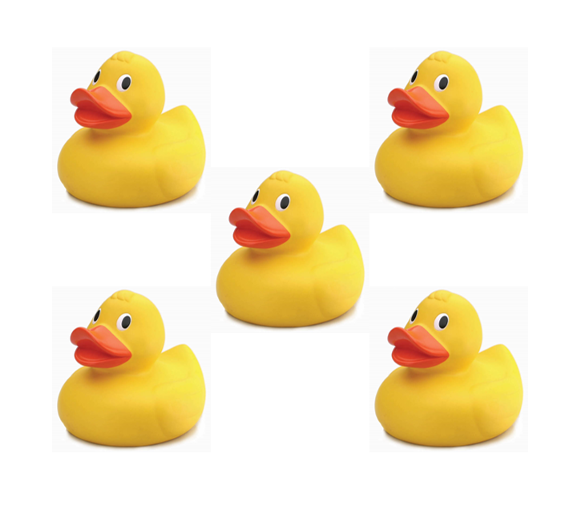
Shape:
- Give your child different objects to explore, such as large stones, pine cones, spoons, a bunch of keys, stacking blocks and balls. Talk about the objects, their shape, colour, edges, size, weight and whether they’re on top, under or next to something.
- Point out shapes and patterns around the house. Talk to your child about things being round, pointy, having corners, or being the same or different.
- Play hiding games, for example hiding a small toy under a cup and asking your child “where’s it gone?” Talk about where you found them - in, on or under?
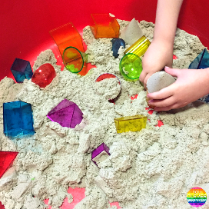
Measures:
- Give your child different sized containers to fill and empty at bath time.
- Find big and small things around the house to match – big spoon and little spoon.

