**Communication Ideas for home**

* 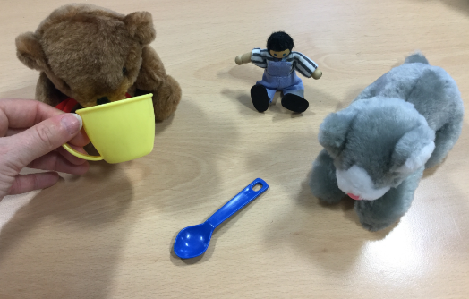Focus on an action word of the day e.g. drink, kick, drive, run, sit, read, pour, stir. Model this action word whenever you can. Encourage your child to use the action in their play e.g. let make the teddy drink or let’s stir the tea. You could google the action word and look at the images of different people doing the action. Get your child to do the action and take a photo of them, make an action album on your phone and look all the action words you have focused on at the end of the week.
* If your child is using single words model combining 2 words throughout the day e.g. if your child says ‘help’ you could say ‘mummy help’ or if your child says ‘sock’ you could say ‘dirty sock’.
* Play a finding game and see if you child can find things around the house e.g. bags, shoes, toothbrush etc. Make the instructions harder by also saying who the item belongs to e.g. can you find Mummy’s coat or Daddy’s sock?
* 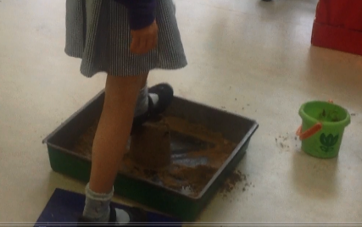Take time to sit still and look out the window together, maybe at home or if you are in the car or on the bus. Talk about what you can see. You could even play I spy using describing words e.g. I spy something that is red, long, big etc.
* Play turn taking games together, this could be physical games such as taking it in turns to splat sandcastles or jump off the wall. Or you could try more structured games like Pop up Pirate or Jenga.
* Label your child’s emotions throughout the day; using early emotion words such as happy, sad, angry and scared. Or while watching a film see if you can spot how the character feels using an emotion word.
* Set up an obstacle course in your house or garden with household items e.g. cushions, brooms, chairs, buckets and blankets. Use prepositions to direct each other on how to complete it e.g. go *under* the blanket, or step *in* the bucket. Alternatively if your child likes doing their own thing then just comment on what they are doing using words such as in, on, under, next to, behind, in front and over.
* Try teaching the concepts big and little. You could use doll’s house furniture and match it to the bigger real life furniture in your house and identify which one is big and which one is little. You could use play food and compare sizes to the real food you have in your house. You could find your your child’s clothes and compare them to the size of your own identifying which one is big and which one is little.

**Verbs**

**Aim**

To be able to use simple verbs.

**General Advice**

Start with simple verbs, that the child is likely to encounter during the course of the day. Use 2 or 3 verbs at first. When the child can use these consistently, add in new ones. Checklists can be helpful to monitor this. Always check that a child can understand a verb, before you practise saying it.

Note, some children may be able to use a verb when talking about pictures, but may find it harder in ‘real-life’. So it’s important to practise both.

The first verbs children learn to use are:

Brush Eat Sit

Clap Hit Sleep

Cook Jump Stand

Cry Kick Throw

Cut Push Walk

Drink Read Wash

Dry Run

**Action Games**

Daily Routines

Talk about actions as they occur, so that the association between action and word is made clear.

Start with action-verbs that do not involve an object, as these are easier for the child to understand. They describe movements, such as running, sleeping, jumping, which the child can carry out himself.

The adult asks the child ‘What are you doing?’, while they are engaged in a range of activities.

Doll Play

The adult makes a doll carry out actions and asks the child ‘What is she doing?’.

Child and adult can take turns, so the game is more interesting. Describing it as ‘Bossy Teddy or Dolly’ or ‘Dolly’s Being Silly’ can make children more likely to do this.

Miming

The adult mimes actions which the children try to guess.

Simon Says

The child and adult give each other commands. When an adult gives commands, encourage the child to say what they are dong, as they do the action.

**Picture Games**

Use action pictures or photographs (eg LDA). These can be incorporated into many games.

**Reward Games**

Children can be encouraged to name a picture before they do part of a game.

e.g. say the picture then blow the bubbles once

say the picture then you get one piece of the jigsaw

This is sometimes helpful if they find formal work difficult.

**Posting Boxes**

Make a posting box, from an old cardboard box. Draw a face/animal on it and a slit for the mouth. The child must say the name of the picture before they can feed it to the animal.

**Miming**

A series of action cards are placed face down. The child picks a card and mimes the action.

**Vocabulary and Categorisation games**

**Categories**

Most words belong to larger categories, for example a ‘cow’ is an ’animal’. Play games involving categories:

* Sorting pictures into categories (use enclosed pictures). Give your child a mixture of 2/3 categories (e.g animals, food, transport), and ask them to sort the pictures into the 3 groups.
* See how many items you can think of in a category. Categories include; animals, transport, furniture, food, clothes, colours, sports etc. Make it more fun by adding a time limit, e.g 1 minute to think of as many as you can.
* Odd one out games – give your child 3 pictures (e.g cat, horse, orange). Ask them to find the odd one out and explain why (e.g ‘orange is the odd one out because it’s a fruit and the others are animals).
* List items from a category. Can your child guess the category?
* List items and take turns to add one more from the same category.

**Subcategories.**

Most large categories can be divided into smaller subcategories, for example:

Zoo animals Fruit

Animals Farm animals Food Vegetables

Pets Meat

Snacks

Bedroom

Kitchen

Furniture Bathroom

Living room

Play the same games as those above, but making it harder using subcategories rather than broad categories, e.g how many fruit can you think of, list items of bedroom furniture etc.

**Definitions**

Talk about all the things you know about a particular word. What makes it special or different, e.g butterfly 1) is an insect 2) it has wings 3) it can fly 4) it has colours on it’s wings.

Play ‘give me a clue’ games involving a selection of pictures. You will need to choose objects with some similar and some different features so that the choice is not too easy. Take turns with your child to give the clues and to guess.

**Barrier games**

These games help to improve attention, listening, turn taking, co-operation and ability to follow instructions.

**1. Building Towers**

Aim: For the children to build an identical tower by listening to each other, giving and following instructions.

j0232107

* The children need to sit on opposite sides of a table.
* Give each child a set of bricks, make sure they have the same number of bricks in each colour.
* Hold a book between them so they can not see each others bricks.
* Child A chooses a brick and places it in front of them. They then tell child B which brick they have chosen e.g. ‘a blue brick’.
* Child B must listen and then find the same brick.
* Lift the book and encourage the children to check they are right.
* Child A and child B swap roles so they are building an identical tower together.

Extension:

Include a number in the instruction e.g. ‘two red bricks’.

Include bricks of different shapes e.g. ‘a long yellow brick’.

**2. Asking for pictures**

Aim: For the children to gain items by asking. To increase listening and co-operation.

* Use the object pictures attached. (You could use real objects if this is more motivating for the children).
* Give child A a set of the pictures in a pile.
* Give child B an identical set of the pictures spread out on the table.
* Child A takes a picture from the pile, they then must ask for the item on the picture e.g. ‘Can I have a hat please’, to make this easier model a shorter phrase for the children to use e.g. ‘hat please’.
* Child B must listen, find the correct item from their set of pictures and give it to child A.
* Then check the two pictures match.
* Swap roles.

Extension: The children can ask for 2, 3 or 4 items.

**3. Giving instructions**

Aim: To give, and listen to instructions.

* The children need to sit on opposite sides of a table.
* Have 2 sets of identical objects e.g. a cup, a brick, a pencil, a cow.
* Hold a book between them so they can not see each others items.
* Give child A and child B a set of items each.
* Child A must arrange the objects and then give an instruction to child B, e.g. ‘put the pencil in the cup’; ‘put the cow on the brick’.
* Encourage the children to keep the instructions short initially.
* Lift the book and encourage the children to chock they are right.
* Child A and child B swap roles.