Read Write Inc: Phonics at Drumbeat School
Ideas for home
Read Write Inc. Phonics teaches children to read accurately and learn to form each letter. It aims to enable children to read and write independently. Read Write Inc. Phonics has been adapted to meet the varied needs and abilities of pupils at Drumbeat School. Below is a summary of how this has been done and some ideas to continue to promote reading and writing skills at home.
Pathway 1
Vocabulary development
At the earliest stages of learning to read children are still developing their vocabulary. Each letter in Read Write Inc: phonics has an associated picture. See the photo below. At Drumbeat school children practice playing with, finding and labelling these objects
- At home try relating your play to one of the Read Write Inc: phonics objects e.g. for ‘d’ you could try dinosaurs in ice, dinosaur puppets or dinosaur small world play
- At home children could also explore objects beginning with a specific letter as part of play activities. For instance for ‘m’ you could have some wind up mice, milk, mirrors and mountains in a tray and label these as the children play and explore emphasising the first sound e.g. mmmmilk

Sound Play
Playing with sounds is also an important skill for those at the earliest stages of reading. This includes listening to, saying and making sounds.
- Try making symbolic sounds throughout your day e.g. when using the microwave make a ‘whirring’ noise together, when it’s bedtime say ‘shh’, when you see horses in a field say ‘clip clop’, when the wind blows and it’s cold say ‘brrr’ and when you eat some yummy food say ‘mmm’. You can add your own ideas to this list.
- Go on a walk and listen! See if you can hear any vehicles, machinery or nature sound and label things as your hear them. Trying making the noises together.
- Sing songs together! Try missing out words and see if your child can join in. Make up songs for your everyday activities and add these made up words to familiar tunes. E.g. you could sing ‘brush your teeth do do do do do do brush your teeth’ to the tune of baby shark.

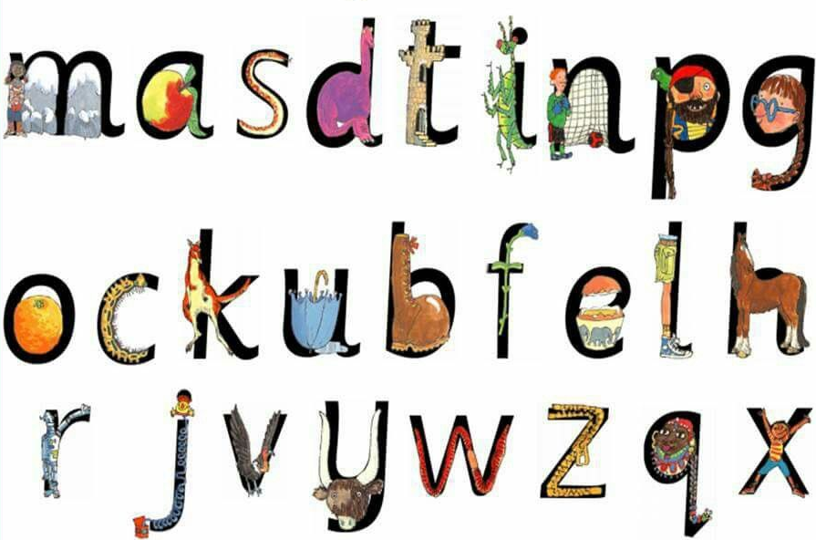

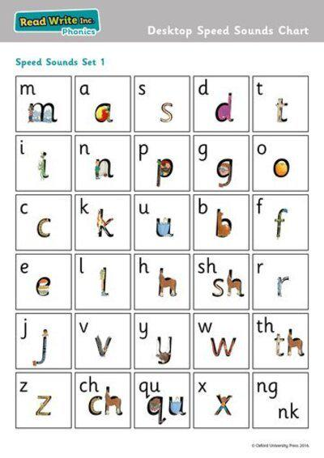
Pathway 2
Children who are beginning to read using phonics learn to say, read and write the sounds in a particular order. See the Speed sound set 1 photo.
- You could choose a different sound each day or week to practise saying, reading and writing with your child. See the Read Write Inc video on how to say the sounds for more information.
- Trying thinking of as many words as you can that start with that sound or to make it harder thinking of any ‘animals’ or ‘food’
- At home play blending games where you break each word up into their separate sounds so children have to blend the sounds in order to understand e.g. find the ‘c-a-t’ or ‘d-o-g’ or touch your ‘h-air’ or ‘m-ou-th’
- If your child is confident with reading their sounds or writing their letter you could also trying reading and writing words with the ones they know.

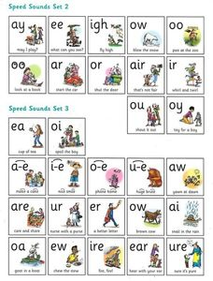
Pathway 3
Children who can already read and spell lots of words will be learning to read more sounds and learning about different ways or reading and writing the same sound. See the speed sounds set 2 and 3 photo.
- Try saying and reading the sounds and think of words that contain that sound e.g. ‘ay’ could include say, may, day, play etc
- If your child is confident with reading these more difficult sounds you could also trying reading and writing words with the ones they know.

For further information on Read Write Inc see this link:
https://www.ruthmiskin.com/en/find-out-more/parents/

For access to free e-books to read at home click on this link:
http://www.oxfordowl.co.uk/Reading/

