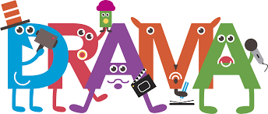 Pathway 2 Activities:

Emotions Game

Skills being developed: Attention, emotional and self-awareness, social.

Spend some time talking to your child about different emotions. To begin with keep the list relatively short, eg. happy, sad, excited, scared, calm, angry. Explain that these words describe how we are feeling, and that people behave, talk and look differently depending on how they are feeling.

Go through each emotion on the list and show your child how your face might look if you are feeling that emotion. Eg. “When I’m feeling happy I smile” – and show them your happy smiling face.

Once you have demonstrated each emotion, tell your child you are going to play a face game. Say aloud an emotion, show them what your face might look when you feel that way and encourage them to copy you, giving guidance and help where needed. After a few go’s, name an emotion and see if they can show you what the emotion looks like before you do it. Eventually, take it in turns to create the face of the emotion after it has been called out.

Variations – things to try:
- Extend the activity into a guessing game. You will show them a face and they will guess what emotion you are feeling. Swap roles once they have got the idea.
- Why not try adding sound effects or even words to your ‘emotion impressions’ eg. grunting when pulling an angry face, or clapping your hands and saying “this is so much fun” when pulling an excited face.
- Add more emotions to the game – Surprise, disgust, brave, sorrow, amused, determined.

Don’t forget…
Help your child in whatever way they need, remind them it is ok to make mistakes, and reward their efforts with praise and positivity!
Family impressions
Skills being developed: Attention and observation, physical awareness and creativity.

To start, list the names of the people who live together in your home and other friends/family that your child is familiar with. This does not need to be a big list – 1 or 2 names minimum, 6-8 max.
Ask your child to choose one that how/she would like to play.
Once chosen, discuss the following points about that person:
- Their voice – how it sounds when they speak and the typical things they like to say. Eg. “Dad talks with a deep voice and says ‘Ooo that’s great’ when he eats food he likes”.
- Their face – Do they frown/smile a lot when they talk? Are their eyes wide or narrow?
- Their body – Do they have a straight/slouchy posture when they walk? Do they like to put their hands on their hips or cross their arms a lot? What about gestures – do they move their hands a lot when they talk, point at things, or touch their face/hair lots?
As each point is discussed, encourage your child to try to act it out (demonstrate to them as much as is required).
Now you have practiced each characteristic one at a time, see if together you can put all those characteristics together by performing an impression of that person. This can be as simple as asking them to stand like the person whilst saying a simple word or phrase (eg. pretending to be Grandma saying “Oh Goodness”), or as elaborate as acting out a short sketch (eg. doing a full impression of a younger sibling playing with his/her favourite toy).
These can go on for as long as your child is engaged in the activity, and you can impersonate as many different people as you like – focussing each time on what personal characteristics you identify them with. Remind your child to keep the impressions respectful and kind (you are not ‘taking the mickey’ out of others), and keep it fun!
Don’t forget…
Help your child in whatever way they need, remind them it is ok to make mistakes, and reward their efforts with praise and positivity!
Ways to move/travel

Skills being developed: Creativity, gross motor, physical control and special awareness.

This activity can be done in the garden or in an open space indoors (eg. Living room) – it does not need to be a big space, but useful to not have any small objects on the floor that you could trip over.

Stand in the space and say “we are standing still”.

One your child is still, say “let’s walk”, and begin to walk slowly around the space, either in a random direction or in a circle if you prefer. If needed – hold your child’s hand or guide them with one hand on their shoulder.

After a few seconds, say “STOP! Now we are on a bike. GO!”
Start to move around the space again, but this time pretending to ride a bicycle.

Once you have travelled a few times around in the circle in this way, say “STOP! Now we are walking in sticky, gooey mud. GO!” and begin walking around as if you are squelching through mud.

Keep repeating, instructing your child to move in the following ways:

- Driving a car
- Like a King/Queen
- Swimming
- Like a soldier
- Riding a horse
- Like a robot
- On ice
- Through a blizzard/snow storm
- Like an astronaut on the moon
- In the dark

Feel free to add any other ways to move that you think your child would enjoy!

Don’t forget…
Help your child in whatever way they need, remind them it is ok to make mistakes, and reward their efforts with praise and positivity!

What am I doing?
Skills being developed: Observation and attention, communication and creativity.

To begin, tell your child that you are going to mine (act out) something, and their job is to guess what you are doing. Choose a simple action eg. brushing your hair, and act it out for them. If they guess correctly, then move on to the next one. If not, give them a choice of 2, eg. “am I brushing my hair or tying my shoelaces?” and see if they can guess.

Once you have acted out a few, try and encourage your child to have a go. They might need you to give them suggestions of things they can act out, or ways to portray it. Give them whatever help they need and encourage them to be as independent as possible – they may feel quite self-conscious to begin with and will need lots of encouragement with no pressure to perform if they are not ready to do so.

Eventually the game can evolve into a turn taking game (between 2 or more of you), and (depending on your child’s needs) you can even add competition to the game by awarding a point for every correctly guessed action.

Below are a list of suggestions of things that you can act out:

- Eating a burger
- Digging a hole
- Blowing out candles
- Eating a packet of crisps
- Bouncing a ball
- Putting on trousers
- Brushing your hair
- Blowing your nose
- Playing tennis
- Painting a picture
- Taking a photo
- Washing the dishes
- Frying a pancake
- Drinking tea
- Chopping vegetables
- Typing on a laptop
- Playing football
- Playing a computer game
- Reading a book
- Driving a car
- Talking on the phone
- Tying your shoelaces
- Brushing your teeth
- Making a cake
- Putting on your coat
- …any others you can think of!

Variations – things to try:
- Add in sound effects to your acting to make the actions more interesting and clear.
- Extend the actions into a mini ‘scene’ in which you narrate as you go. Eg. “Right, where are my eggs? Ah here they are (pretend to break eggs into a bowl). Sugar next, let me measure it out…(pretend to measure sugar and pour it into the bowl and stir it up).” Etc.
This can make the acting easier to understand and more entertaining as you can add humour to the scene to keep them interested – “oops, dropped an egg on the table, ugh look it’s all over my hands!”

Remember to keep your actions simple and clear to begin with, building them up as your child becomes more familiar with the game and starts to need more of a challenge. Most importantly ensure to keep it light hearted and fun so that their confidence in performing builds.

Don’t forget…
Help your child in whatever way they need, remind them it is ok to make mistakes, and reward their efforts with praise and positivity!

The storm
Skills being developed: Attention, social skills, physical control and creativity.

This activity is all about using your body to create sound effects and can be done in a pair or in a group. The idea is to gradually build up the sounds to a crescendo, and then gradually quieten them down again to silence.
Sit across from your child and tell them that you are going to use your bodies to create the noises of a storm. They must copy the actions that you do.
Say the following lines, followed by the described action (doing it for long enough that your child has had time to see the action, copy the action, listen to the sound it makes and enjoy it):
“Outside, it was still and quiet” – do nothing.
“A gentle breeze was heard” – rub your hands together slowly
“The breeze grew louder” – Rub your hands together quickly
“A pitter-patter of rain was heard” – tap 2 fingers on the palm of your hand
“The rain came down heavier” – clap your hands lightly
“Then it started to pour” – clap your hands fast and loud
“It began to thunder” – stamp your feet twice (whilst clapping)
“The thunder rumbled closer” – stamp your feet continuously whilst clapping
“Crack went the lightening overhead” – clap your hands once over your head whilst stamping
“As the storm began to pass the thunder moved away” – stop stamping, keep clapping
“The rain began to calm” – clap your hands lightly
“The rain turned to drizzle” – tap 2 fingers on the palm of your hand
“The rain stopped as the wind blew away the clouds” – rub your hands together quickly
“As the wind calmed down the sun came out” – rub your hands together slowly
“The gentle breeze stilled, and all was quiet again” – stop rubbing hands.

As each new action is introduced, you may need to verbally prompt your child to change actions eg. “look at my hands, I’m clapping now, clap with me”.
Don’t forget… Visuals below to support activities
Help your child in whatever way they need, remind them it is ok to make mistakes, and reward their efforts with praise and positivity!
Pathway 2 Activities:
VISUAL AIDS

Emotions Game

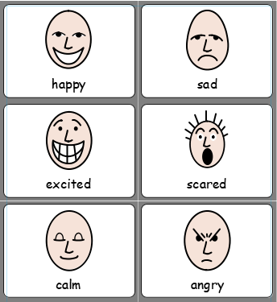

Family impressions
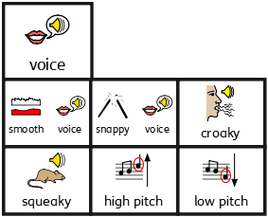
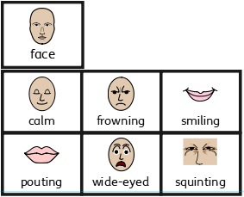
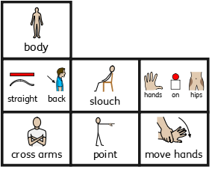
Ways to move/travel

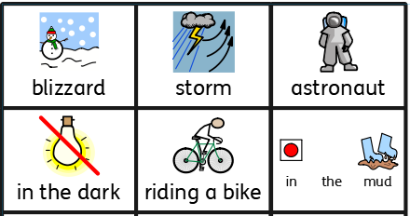
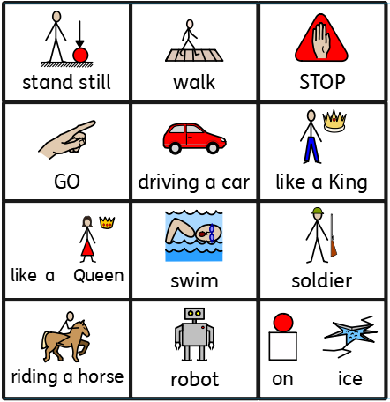

What am I doing?

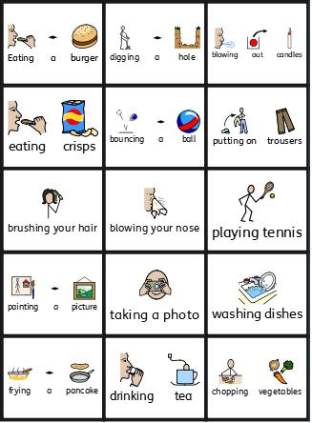

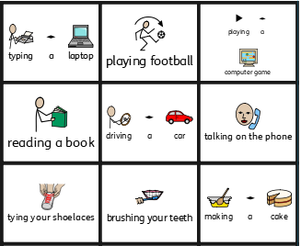

The storm
